Computer Networks

Lab Task #5

Saad Ahmad

20P-0051

Task#1

Add 2x PCs, 1x Router and 1x Server.

Connect them with cables.

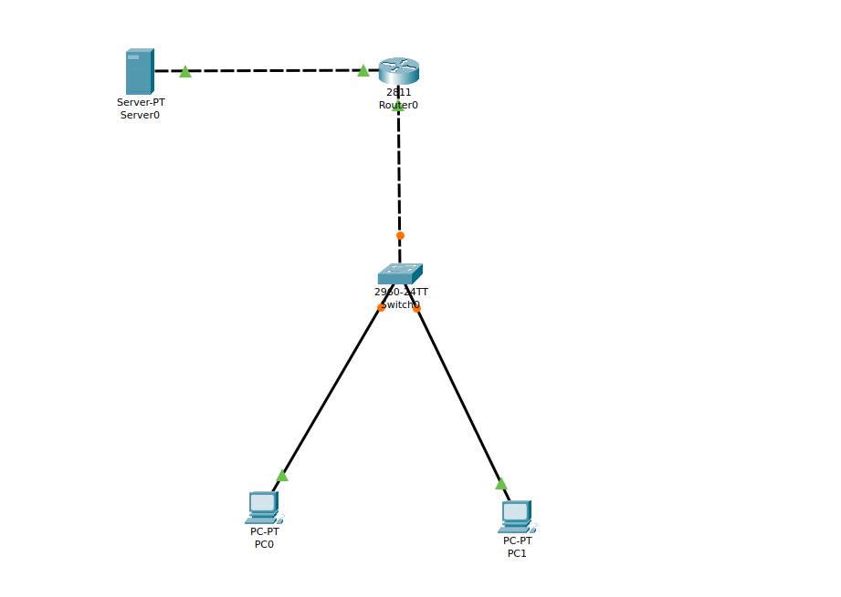

Now assign the static IP to the sever

**IP:** 192.168.1.2

**Subnet mask:** 255.255.255.0

**Default gateway:** 192.168.1.1

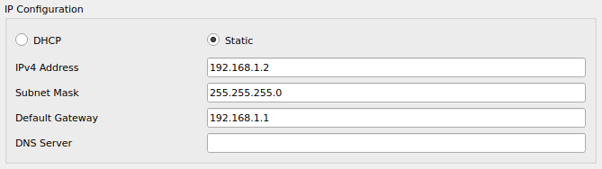

Now we’ll configure DHCP server pool.

Click on DHCP Server→Services→DHCP.

Turn ON the DHCP service on the server and create a pool.

**Pool Name:** SALES

**Default Gateway:** 192.168.2.1

**DNS server:** 192.168.1.2

**Start IP address:** 192.168.2.0

**Subnet Mask:** 255.255.255.0

**Maximum no. of Users:** 255

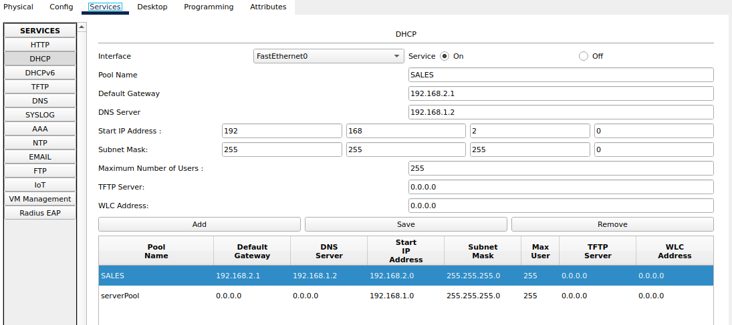

Now we will configuration the Router interfaces and we will add the helper ip address as well.

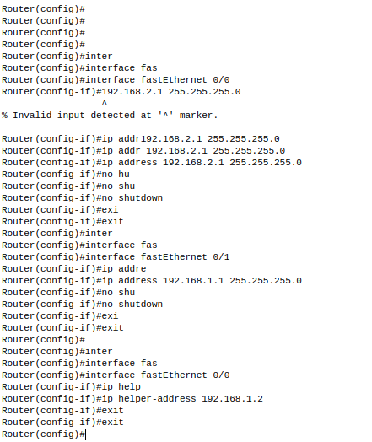

And now enable DHCP on the PCs in SALES LAN. The PCs will obtain their address from the DHCP server.

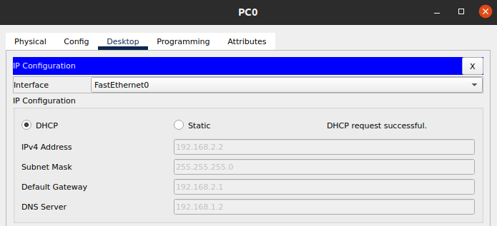

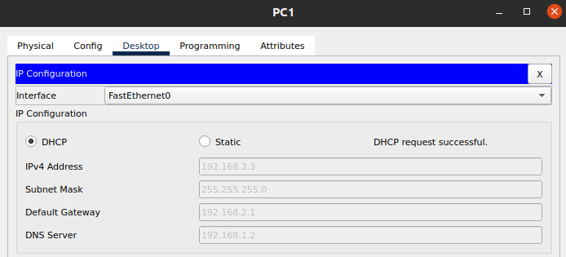

Task #2

Add 6x PCs, 2x Switches, 1x Router and 5x Server.

And connect them with cables.

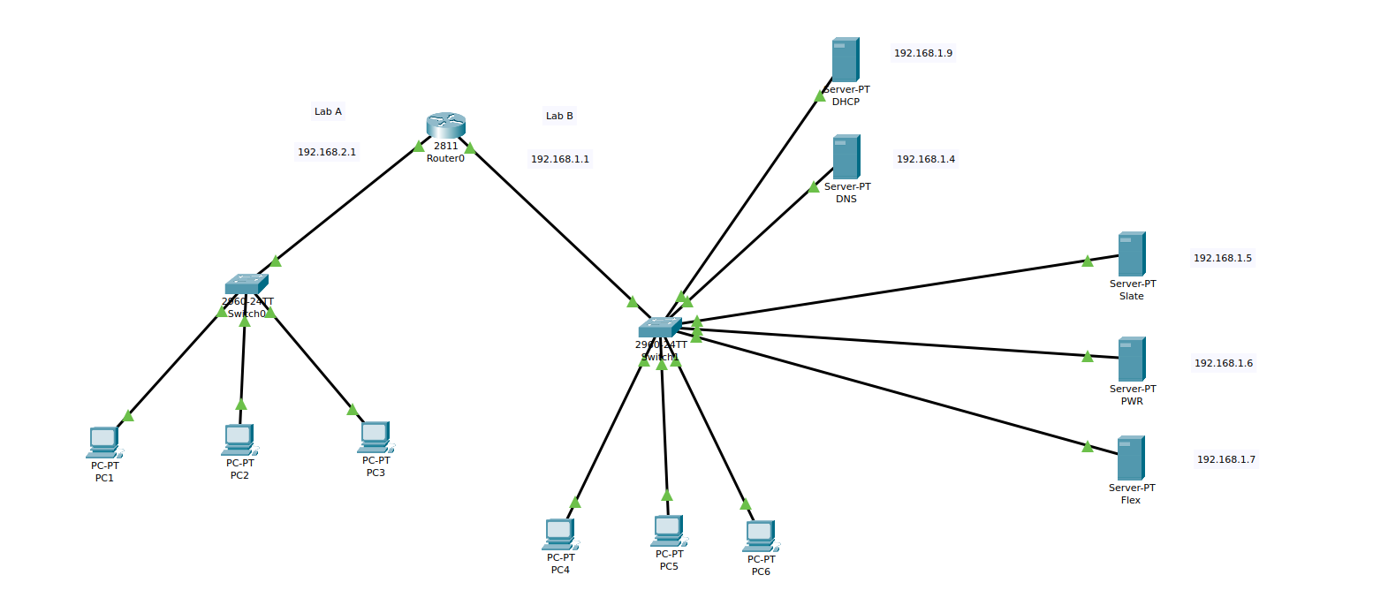

Three are the website servers:

• (www.slate.com ) having IP address 192.168.1.5

• (www.pwr.com ) having IP address 192.168.1.6

• (www.flex.com ) having IP address 192.168.1.7

Now assign the static IP to the DHCP Sever

**IP:** 192.168.1.9

**Subnet mask:** 255.255.255.0

**Default gateway:** 192.168.1.1

**DNS Server:** 192.168.1.4

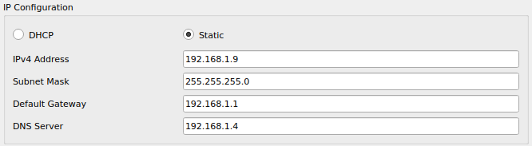

Now create two pools so for that click on DHCP Server→Services→DHCP.

Turn ON the DHCP service on the server and create a pool.

**Pool #1**

**Pool Name:** serverPool (as Lab B)

**Default Gateway:** 192.168.1.1

**DNS server:** 192.168.1.4

**Start IP address:** 192.168.1.10

**Subnet Mask:** 255.255.255.0

**Maximum no. of Users:** 200

**Pool #2**

**Pool Name:** Lab A

**Default Gateway:** 192.168.1.1

**DNS server:** 192.168.1.4

**Start IP address:** 192.168.2.0

**Subnet Mask:** 255.255.255.0

**Maximum no. of Users:** 200

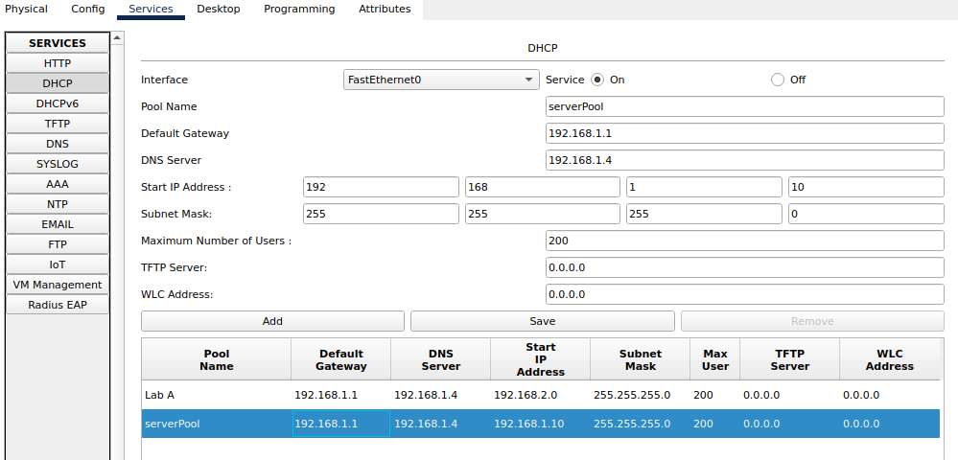

Now assign the static IP to the DNS Server.

**IP:** 192.168.1.4

**Subnet mask:** 255.255.255.0

**Default gateway:** 192.168.1.1

**DNS Server:** 192.168.1.4

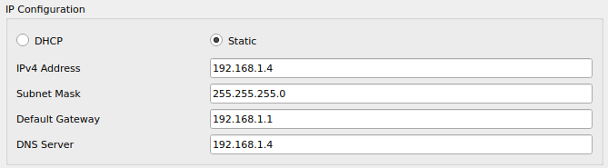

Now we will record the data of the webservers so for that click on DNS Server→Services→DNS.

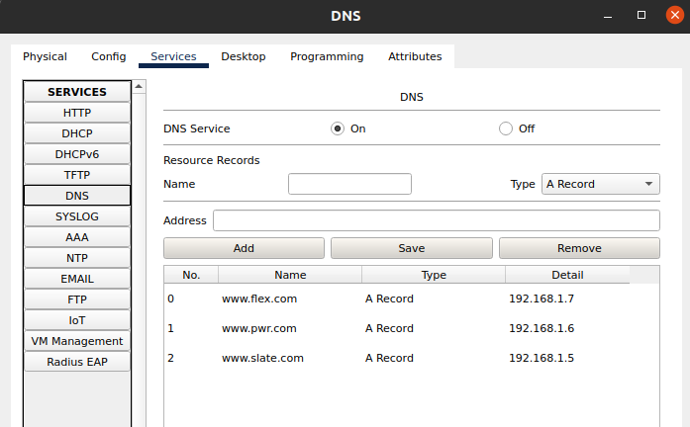

Remember to turn **“ON”** the DNS Service

And now we will configure our router so for that go to the router and click CLI.

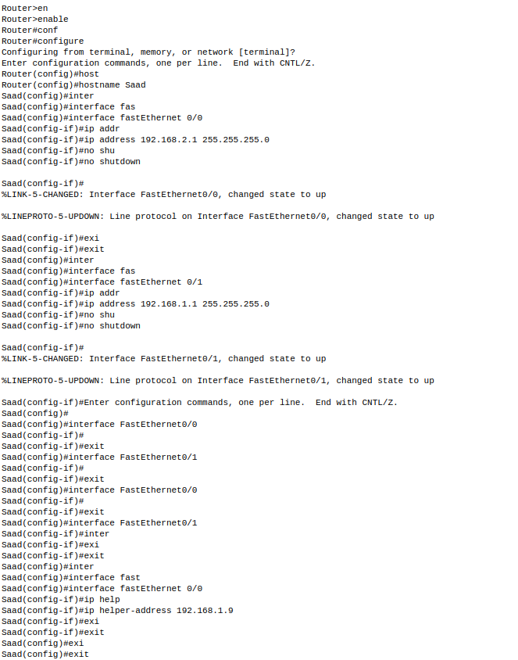

Now all of our devices are configured and we will assign the IPs to our PCs dynamically so for that enable DHCP on the PCs in Lab A and Lab B. The PCs will obtain their address from the DHCP server.

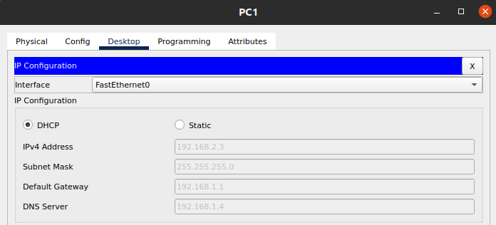

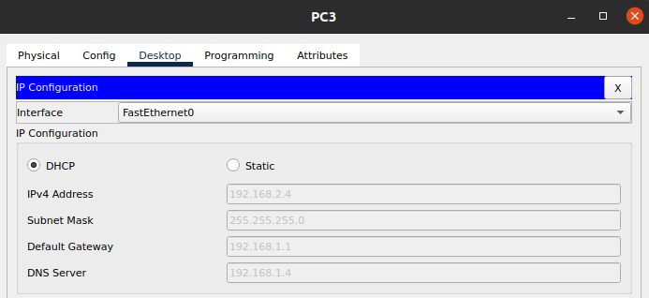

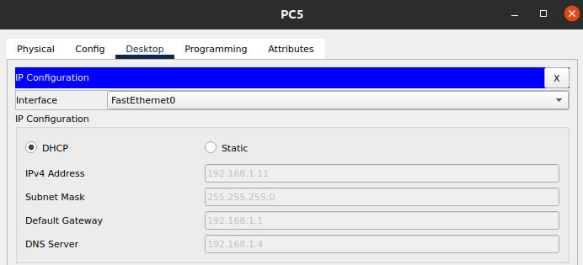

**Results:**

**Lab A**

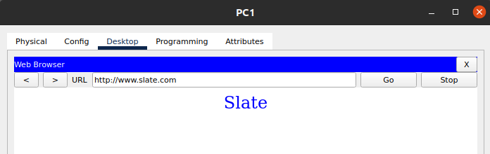

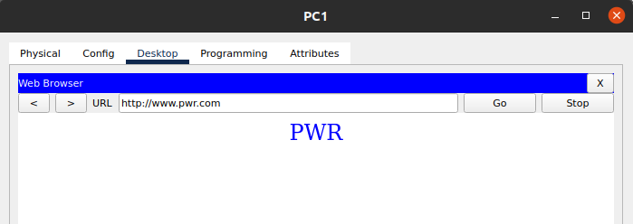

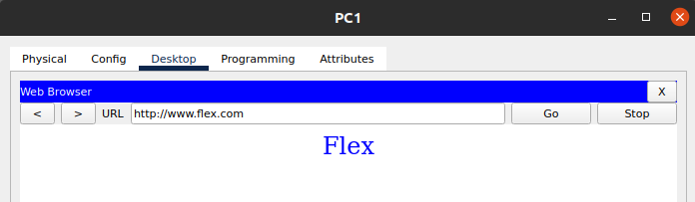

**Lab B**

